Data Types in Java
Data types specify the different sizes and values that can be stored in the variable. There are two types of data types in Java:
- Primitive data types: The primitive data types include boolean, char, byte, short, int, long, float and double.
- Non-primitive data types: The non-primitive data types include Classes, Interfaces, and Arrays.
Java Primitive Data Types
In Java language, primitive data types are the building blocks of data manipulation. These are the most basic data types available in Java language.
Java is a statically-typed programming language. It means, all variables must be declared before its use. That is why we need to declare variable's type and name.
In Java, there are mainly eight primitive data types and let's understand about them in detail in the following paragraphs.
Java Primitive data types:
- boolean data type
- byte data type
- char data type
- short data type
- int data type
- long data type
- float data type
- double data type
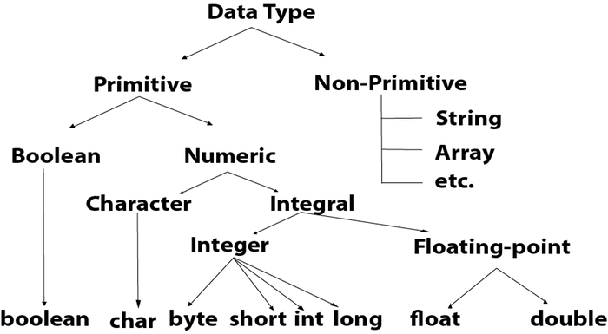
Data Type | Default size
Boolean | 1 bit
Char | 2 byte
Byte | 1 byte
Short | 2 byte
Int | 4 byte
Long | 8 byte
Float | 4 byte
Double | 8 byte
Boolean Data Type
In Java, the boolean data type represents a single bit of information with two possible states: true or false. It is used to store the result of logical expressions or conditions. Unlike other primitive data types like int or double, boolean does not have a specific size or range. It is typically implemented as a single bit, although the exact implementation may vary across platforms.
Example:
- Boolean a = false;
- Boolean b = true;
Byte Data Type
The byte data type in Java is a primitive data type that represents an 8-bit signed two's complement integer. It has a range of values from -128 to 127. Its default value is 0. The byte data type is commonly used when working with raw binary data or when memory conservation is a concern, as it occupies less memory than larger integer types like int or long.
Example:
- byte a = 10, byte b = -20
Short Data Type
The short data type in Java is a primitive data type that represents a 16-bit signed two's complement integer. It has a range of values from -32,768 to 32,767. Similar to the byte data type, short is used when memory conservation is a concern, but more precision than byte is required. Its default value is 0.
Example:
- short s = 10000, short r = -5000
Int Data Type
The int data type in Java is a primitive data type that represents a 32-bit signed two's complement integer. It has a range of values from -2,147,483,648 to 2,147,483,647. The int data type is one of the most commonly used data types in Java and is typically used to store whole numbers without decimal points. Its default value is 0.
Example:
- int a = 100000, int b = -200000
Long Data Type
The long data type in Java is a primitive data type that represents a 64-bit signed two's complement integer. It has a wider range of values than int, ranging from -9,223,372,036,854,775,808 to 9,223,372,036,854,775,807. Its default value is 0.0F. The long data type is used when int is not large enough to hold the desired value, or when a larger range of integer values is needed.
Example:
- long a = 100000L, long b = -200000L
Float Data Type
The float data type in Java is a primitive data type that represents single-precision 32-bit IEEE 754 floating-point numbers. It can represent a wide range of decimal values.
Example:
- float f1 = 234.5f
Double Data Type
The double data type in Java is a primitive data type that represents double-precision 64. Its default value is 0.0d. It provides a wider range of values and greater precision compared to the float data type.
Example:
- double d1 = 12.3
Char Data Type
The char data type in Java is a primitive data type that represents a single 16-bit Unicode character. It can store any character from the Unicode character set, that allows Java to support internationalization and representation of characters from various languages and writing systems.
Example:
- char letterA = 'A'

Non Primitive Data Types
Class
One common non-primitive data type in Java is the class. Classes are used to create objects, which are instances of the class. A class defines the properties and behaviors of objects, including variables (fields) and methods. For example, you might create a Person class to represent a person, with variables for the person's name, age, and address, and methods to set and get these values.
Interface
Interfaces are another important non-primitive data type in Java. An interface defines a contract for what a class implementing the interface must provide, without specifying how it should be implemented. Interfaces are used to achieve abstraction and multiple inheritance in Java, allowing classes to be more flexible and reusable.
Arrays
Arrays are a fundamental non-primitive data type in Java that allow you to store multiple values of the same type in a single variable. Arrays have a fixed size, which is specified when the array is created, and can be accessed using an index. Arrays are commonly used to store lists of values or to represent matrices and other multi-dimensional data structures.
Enum
Java also includes other non-primitive data types, such as enums and collections. Enums are used to define a set of named constants, providing a way to represent a fixed set of values. Collections are a framework of classes and interfaces that provide dynamic data structures such as lists, sets, and maps, which can grow or shrink in size as needed.

